**JENKINS TASK 02**

**1) Configure 2 slave machines in jenkins master.**

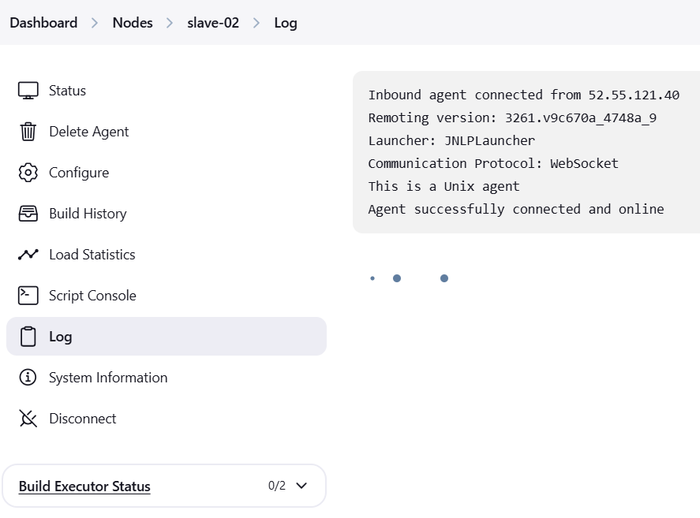 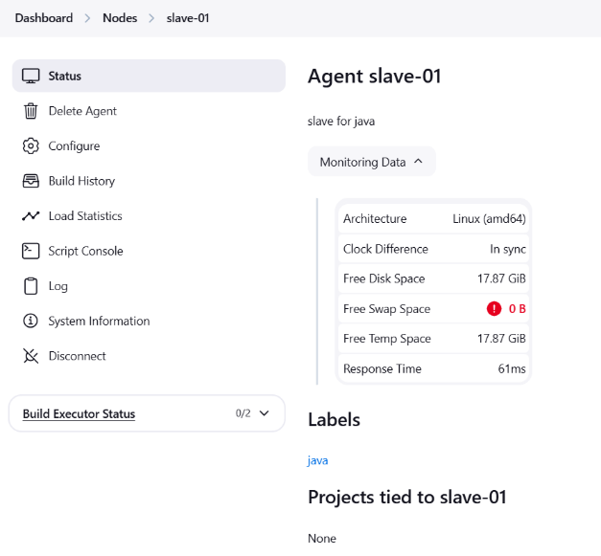

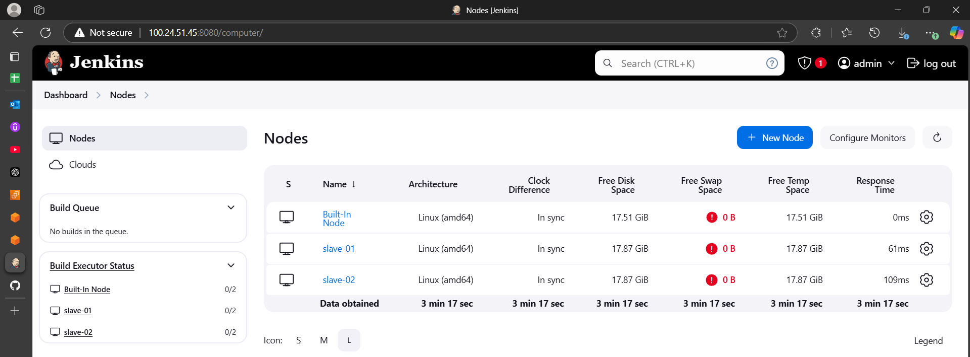

**2) Configure webhooks to jenkins job.**

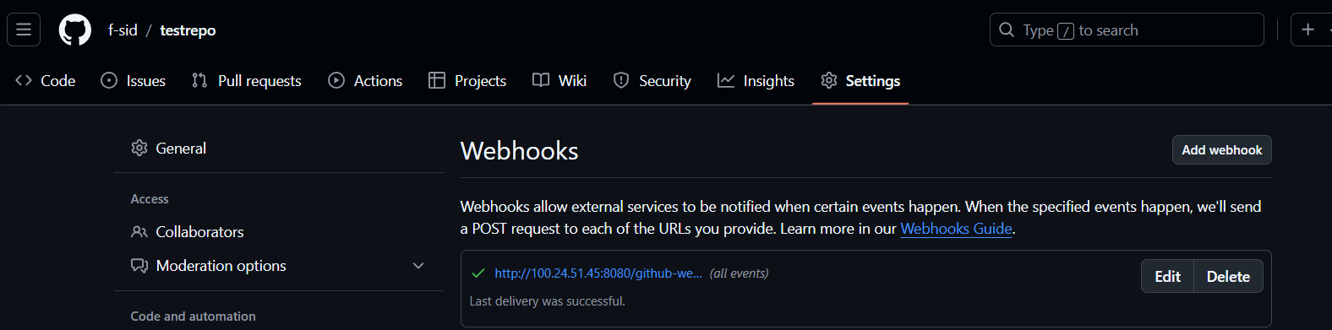

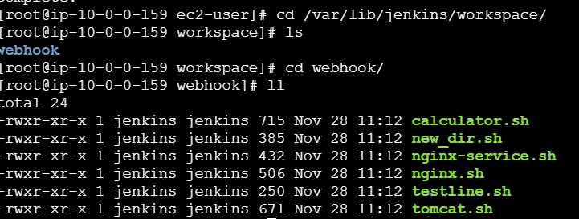

**3) Configure poll scm and build periodical options in jenkins job.**

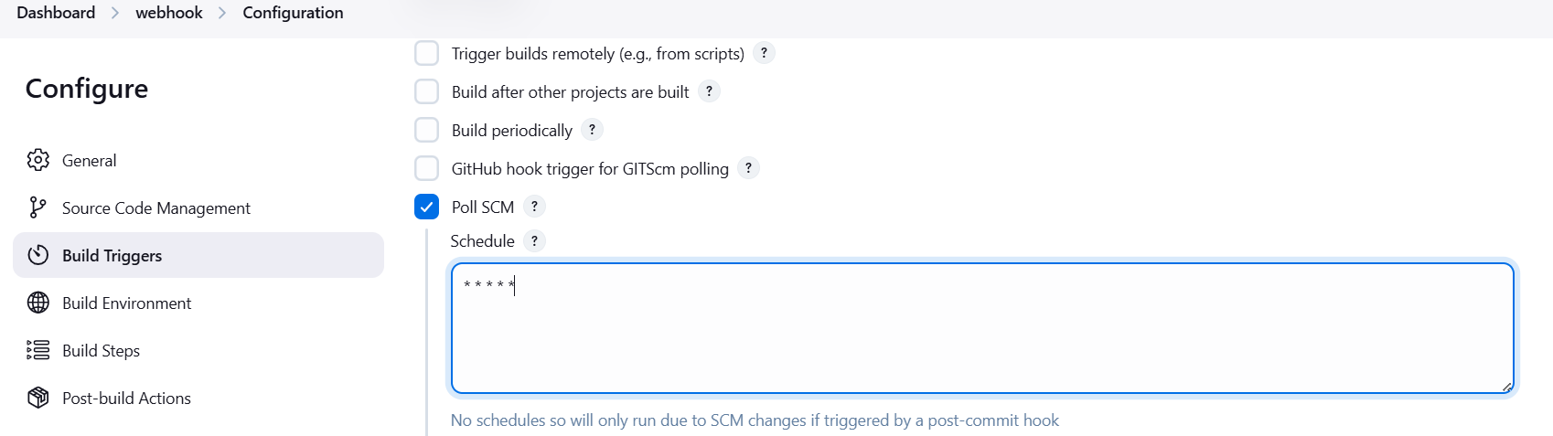

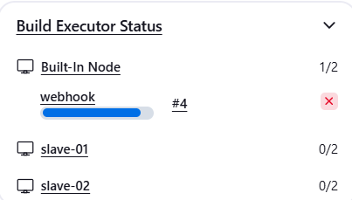 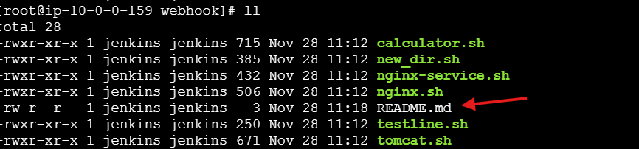

**4) Take backup of jenkins server by using bash script.**

#!/bin/bash

# Define the path to JENKINS_HOME and the backup directory

JENKINS_HOME="/var/lib/jenkins"

BACKUP_DIR="/var/lib/jenkins-backup"

BACKUP_NAME="jenkins-backup.tar"

# Create a backup directory if it doesn't exist

mkdir -p $BACKUP_DIR

# Create a timestamped archive of JENKINS_HOME

tar -cvf $BACKUP_DIR/$BACKUP_NAME $JENKINS_HOME

# Print a message indicating the backup is complete

echo "Backup completed: $BACKUP_DIR/$BACKUP_NAME"

# Add a cron job to schedule the backup script

(crontab -l 2>/dev/null; echo "0 0 * * * /path/to/jenkins-backup.sh") | crontab -

# Print a message indicating the cron job has been added

echo "Cron job added to run the backup script daily at midnight"

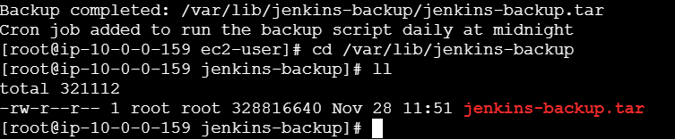

**5) Take backup of jenkins using rethin backup plugin.**

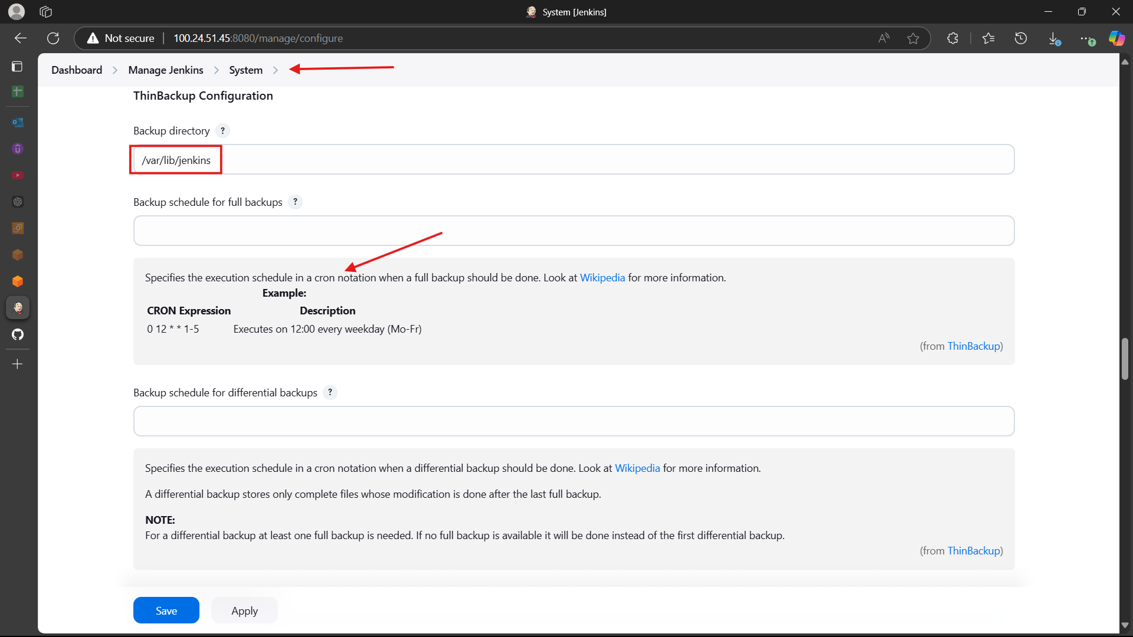

>>restart jenkins after configuring the tinbackup configurations

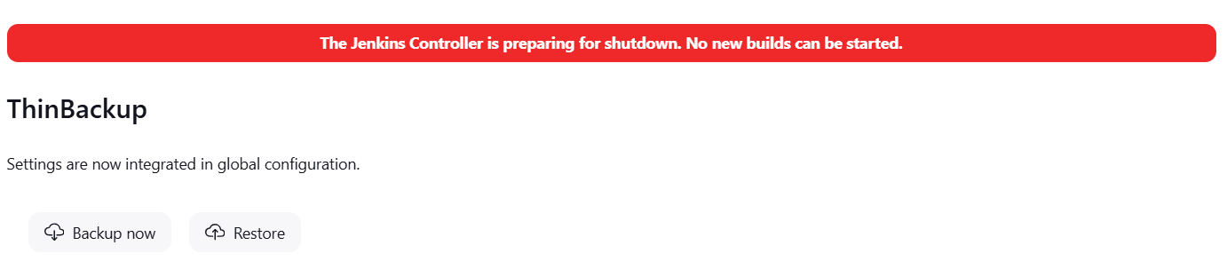

>>checking the restore if backup is available

